Quick Sheet: Grant Notes
Audience: HUD Grantees

Purpose
To add a grant note stating grantee acceptance of award terms and conditions.

Steps
- From an Internet browser (such as Internet Explorer, Google Chrome, or Mozilla Firefox), go to www.grantsolutions.gov.
- The “Grants Center of Excellence” Home page appears. Click the button Login to GrantSolutions.
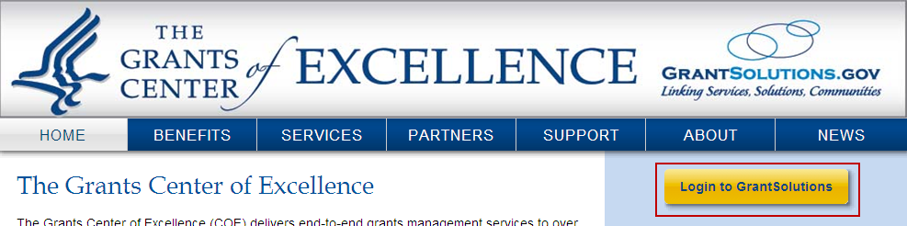
- The GrantSolutions “Login” screen appears. Enter the username in the Username field and the password in the Password field.
- Click the Login button.
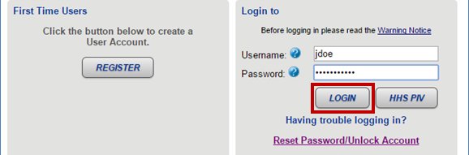

- The “My Grants List” screen appears. Locate the desired grant in which to add your acceptance note.
- The “Grant Notes” screen appears in a new window. The top portion of the screen contains the Grant information and the middle section contains search fields that may be used to locate specific Grant Notes. The search fields are follows:
  - Grant Note Create Date: From and To dates
  - Grant Note Type: Correspondence
  - Grant Note Category: Pre-defined categories
  - Author: Name of user that created the Grant Note
  - Subject: Grant Note subject
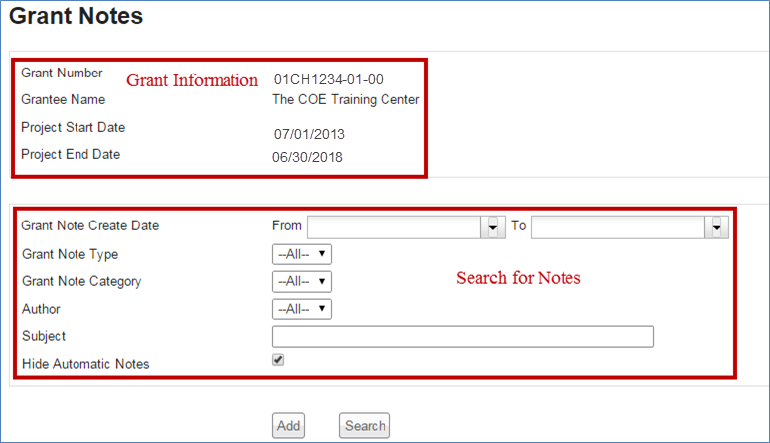

- To add a new note, scroll down towards the bottom of the window and click the Add button.
- The “Grant Notes-Add” screen displays. Complete the following information:
  - Subject: Please Enter “
  - Note Type: Correspondence is the only option and is automatically selected
  - Category Type: From the drop-down list, select Other
Notes: Please Enter “
  - Note Attachments (Optional): Attach one or more files by entering a file description and uploading the following:
- HUD-50080-SCMF
- HUD-91186A
- HUD-92456, Semi-Annual Performance Report
- Quality Assurance Report
- Other

- When done, click the Submit button.

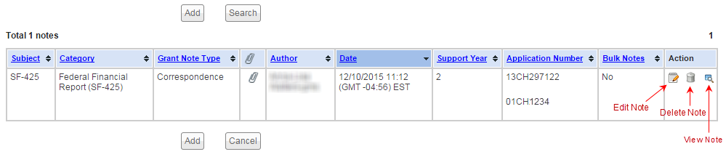
- Click the Cancel button to close the window and return to the “My Grants List” screen.
